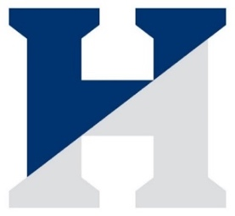 The Hill School Field Hockey Roster
Coaches: Jennifer Weissbach
Gabby Gomez
Alli Lokey

# | Name | Year | Position | Hometown
1 | Abigail Gerdeman | 2026 | M/F | Chester Springs, PA
2 | Anna Cowan | 2024 | F | Portsmouth, NH
3 | Katherine Longo | 2023 | D | Charlotte, NC
4 | Piper Schmidt | 2023 | M/D | Wilmington, DE
5 | Ella Kaplan | 2025 | F | Shaker Heights, OH
6 | McKay Allain | 2023 | F | Pottstown, PA
7 | Riley Savage | 2025 | F | Charlotte, NC
8 | Emilie Kirschner | 2023 | M | Chapel Hill, NC
9 | Sofia Ferri | 2026 | D | Phoenixville, PA
10 | Aubrey Turner | 2025 | F | Downingtown, PA
11 | Opal Sparling | 2026 | M | Chester Springs, PA
12 | Margaret Kondrath | 2023 | M | Downingtown, PA
14 | Annabella Schafer | 2023 | M/D | Ardmore, PA
15 | Taylor Bigbie | 2025 | M/F | Rocky Point, NY
16 | Macy Rehak | 2026 | D | Phoenix, MD
17 | Paige Hartshorn | 2023 | M/D | Granville, OH
18 | Caeli Robinson | 2023 | D | Fort Lee, NJ
20 | Jaedyn Scarlatos | 2024 | F/M | South Setauket, NY
21 | Eleanor Molyneaux | 2023 | D | Fair Haven, NJ
24 | Kerry Elliott* | 2023 | D | Blue Bell, PA
86 | Natane King | 2025 | GK | Haverford, PA
88 | Hala Silverstein* | 2023 | GK | Glenwood, MD
99 | Addy Collingwood | 2025 | GK | Collegeville, PA
*Captains
Managers: Kelly Dempsey ’23 and Abigail Hicks ‘24
Head of School: Zack Lehman
Director of Athletics: Seth Eilberg
Athletic Trainers: Stephanie Schaldonat, ATC, Gregory Macionsky, ATC; Jessica Lydon, ATC

