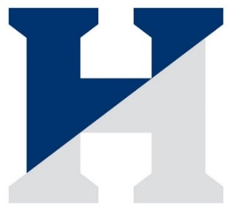 The Hill School Softball Roster
Coaches: Jon McKee
Shannon Ruane
Samantha Lopez

# | Name | Year | Position | Hometown
1 | Mikhalia Smith | 2022 | OF | Pinecrest, FL
2 | Anna Cowan | 2024 | 2B / OF | Portsmouth, NH
3 | MoniYah Person-Henderson | 2023 | OF | Pottstown, PA
4 | Oluwatoyosi Jaiyesmi | 2022 | OF | Lagos, Nigeria
5 | Annika Palmer | 2024 | OF / 2B | New York, NY
6 | Isabelle DiCampello | 2024 | C | Pottstown, PA
7 | Yijun Lyu | 2025 | OF | Shanghai, China
8 | Yuxi Zhen | 2024 | OF | Beijing, China
9 | Sasha Goldberg | 2024 | OF | Phoenixville, PA
10 | Margaret O’Halloran | 2025 | OF | Charlotesville, VA
11 | Grace Capecci | 2024 | OF | Royersford, PA
12 | Jaelynn Bucinell | 2025 | SS / 2B | Endicott, NY
13 | Yueyi Bao | 2025 | OF | Shanghai, China
14 | Aryanna Bodge | 2023 | P / SS | Pottstown, PA
15 | Jamie Rauch | 2024 | OF | Ramsey, NJ
16 | Kelly Dempsey | 2023 | 1B / 3B | Collegeville, PA
17 | Paige Hartshorn | 2023 | OF / 2B | Granville, OH
18 | Ivy Dietrich | 2024 | 1B / C | Las Vegas, NV
19 | Nicole Leonardo | 2025 | OF | Brooklyn, NY
20 | Oluwadamilola Odubona | 2023 | 1B / OF | Hillside, NJ
21 | Ziyue Ling | 2023 | OF | Kunming, China (Peoples Republic)
22 | Eleanor Molyneaux | 2023 | OF | Fair Haven, NJ
23 | Ashley Espinoza | 2023 | OF | Corona, NY
*Captains
Managers: Carmelita Robinson ‘23 and Olivia Cimorelli ‘23
Head of School: Zack Lehman
Director of Athletics: Seth Eilberg
Athletic Trainers: Stephanie Schaldonat, ATC; Jessica Lydon, ATC; Greg Macionsky, ATC

