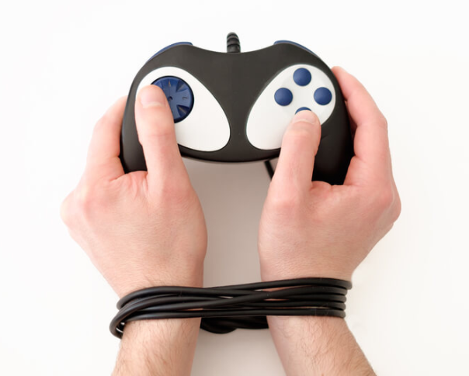

Are you struggling with your teens’ video game playing? Is it affecting your relationship, or creating conflict because they prioritize gaming over academics, family time, social relationships?
Consider watching this short video clip by Dr. Kanojia a leading Psychiatrist who works with video game addiction. He has a program for parents that can help.
You may be asking yourself…is it a phase, will they grow out of it, or why is this important right now. We are more isolated than ever before. Mental illness is on the rise, especially in young people. In young people (ages 10-34) suicide is the #2 leading cause of death (https://nami.org/mhstats). On top of a 11-month pandemic where it’s easier and easier for teens to retreat into the video game world. Here are two videos from Dr. Kanojia that can help start the conversation.
- Healthy Gamer Parent Coaching: What is it About? https://youtu.be/dkdaumrakaQ

- How Video Game Addiction Affects Learning: https://youtu.be/CNRziReRiOY
For more information consider checking out the parent support by Dr. Kanoja on gaming.
https://www.healthygamer.gg/parents/

